To bootstrap a node

Login to your chef workstation, select **cmd** prompt

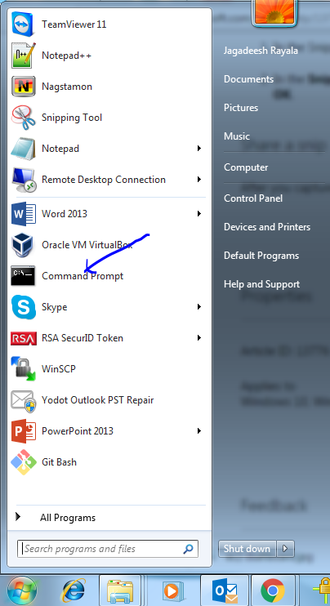

Go to **chef-rep** directory

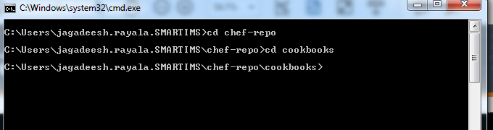

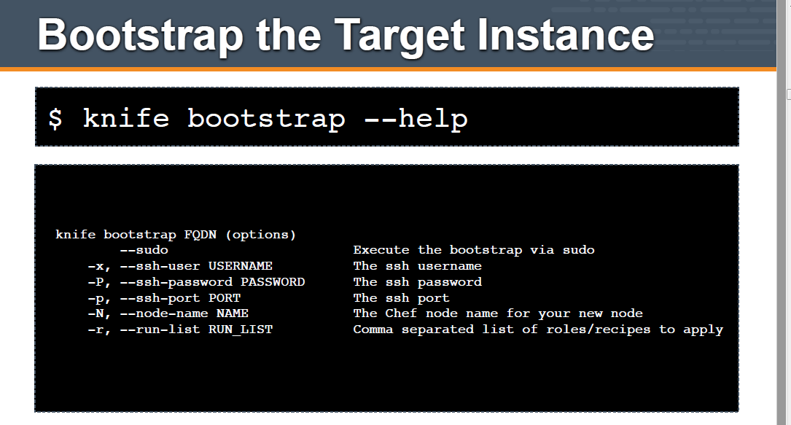

You can run the command

knife bootstrap IPADDRESS --sudo -x username -P password -N “node name” –r “recipe[cookbook name]

Ex: **knife bootstrap 192.168.1.20 –sudo –x root –P test@123 –N node1 –r “recipe[sample]**

